SQL PROJECT

Credit Card Detection

**NAME: SHRADDHA THIK**

**COURSE: MASTER IN DATA SCIENCE AND ANALYTICS WITH AI**

**About Dataset:**

Scams are happening everywhere these days. There are various methods available for you to transact from small to large like online. The project aims to facilitate efficient management of credit card operations, customer accounts and transaction records in a financial institution.

The system is designed to streamline processes related to credit card issuance, account management, transaction tracking and reporting.

**Column Description:**

**\*Card_Holder**

**\*Credit_Card**

**\*Merchant_Category**

**\*Merchant**

**\*Transaction**

DATASET FROM: GitHub

# Entity Relationship Diagram

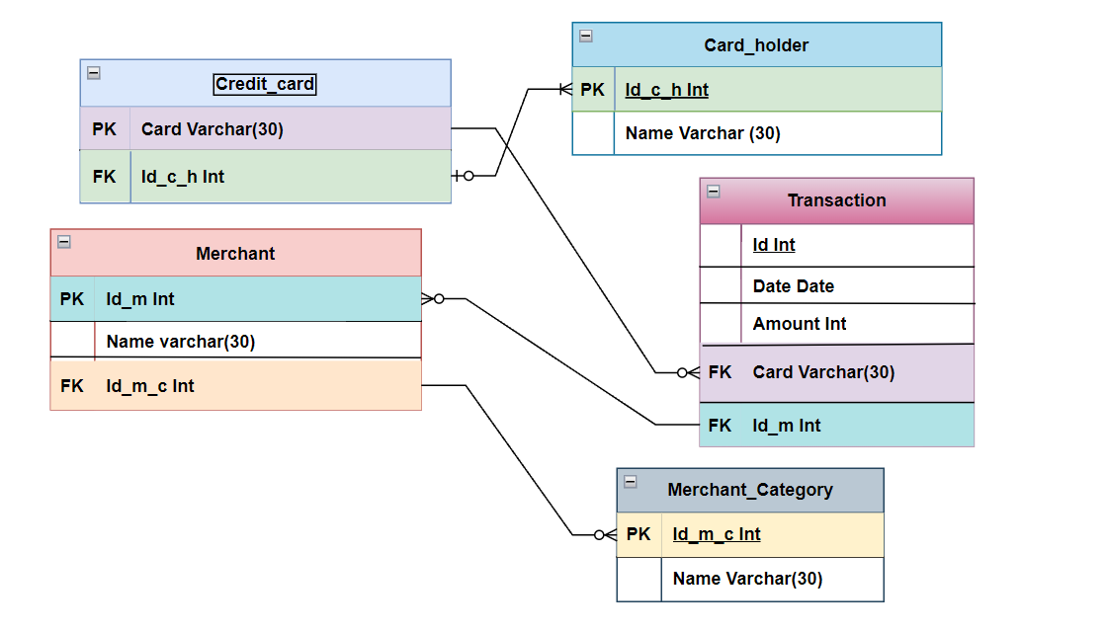

Show schema of the tables

Card Holder

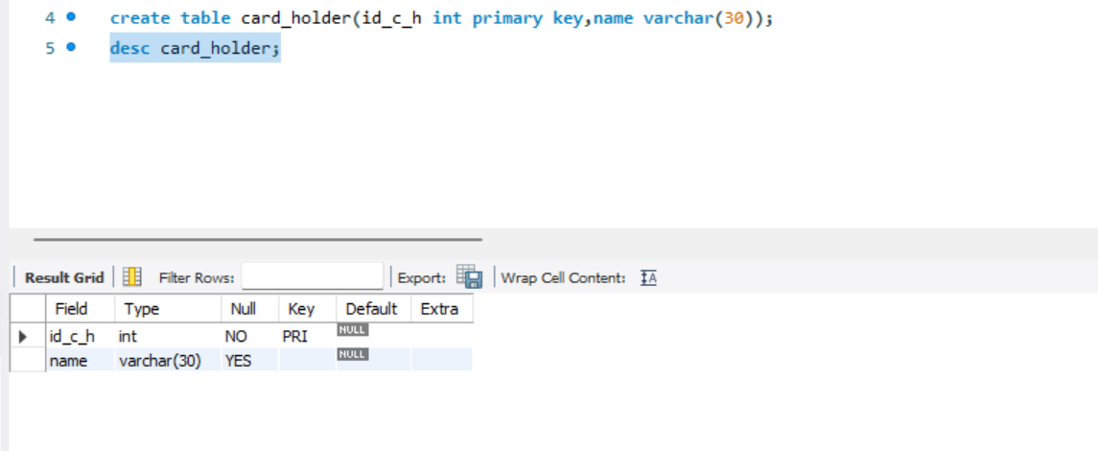

Credit Card

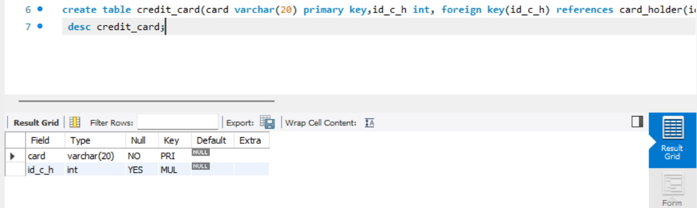

Merchant Category

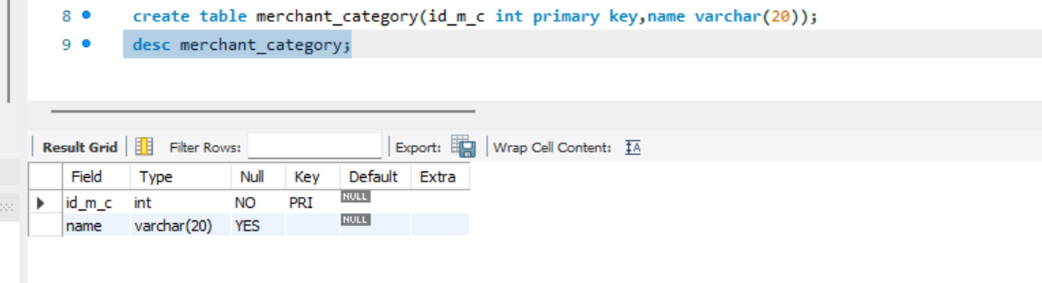

Merchant

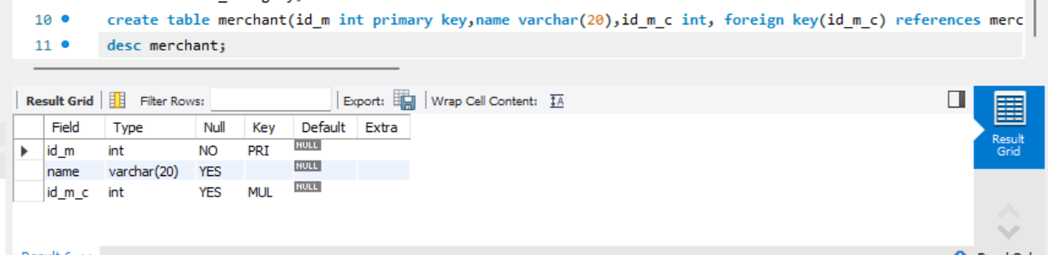

Transaction

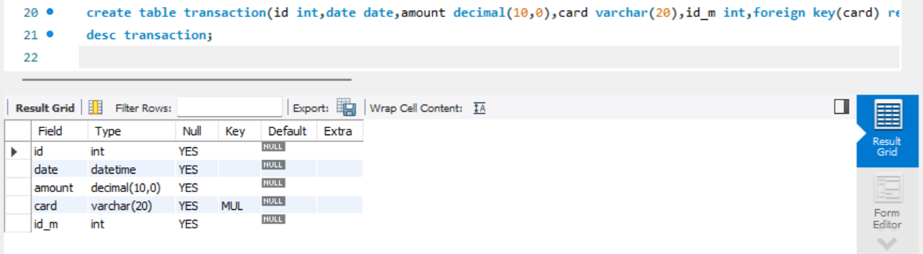

Show Whole Tables

Card_holder

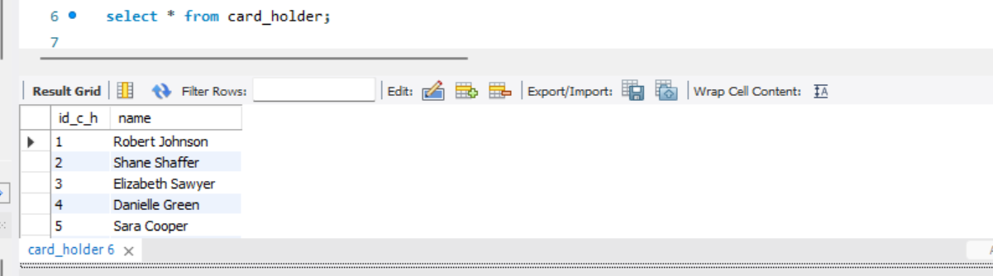

Credit_card

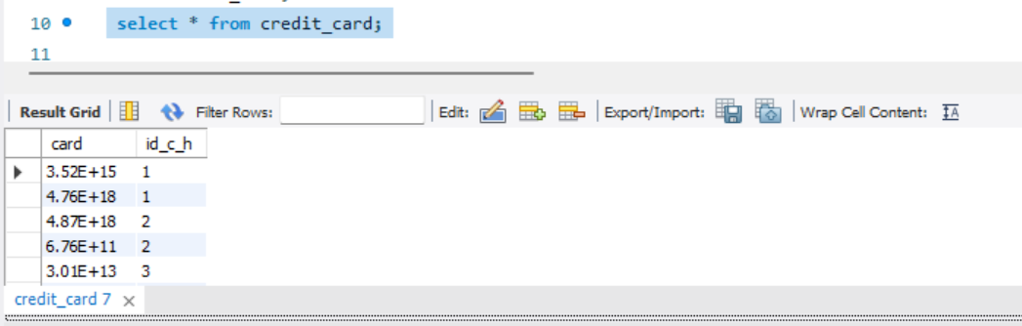

Merchant_category

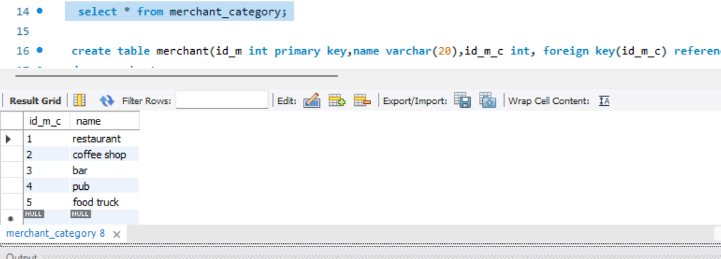

Merchant

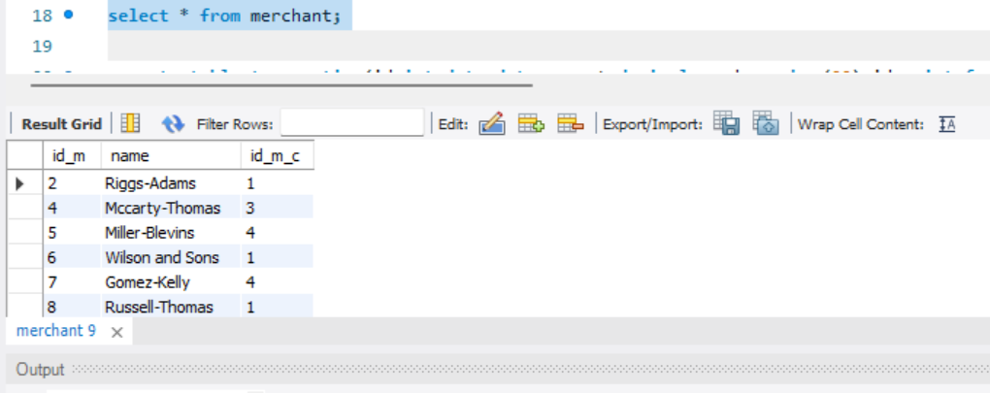

Transaction

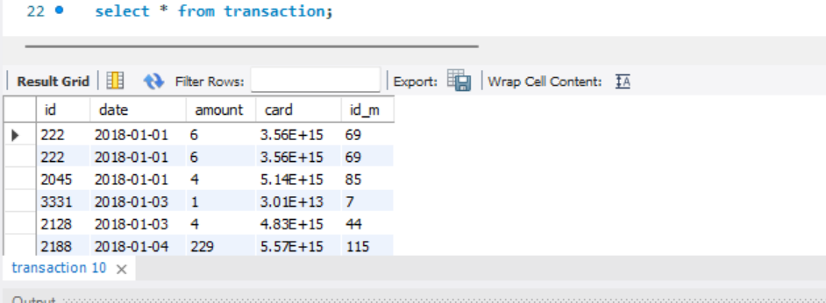

1. Change the data type

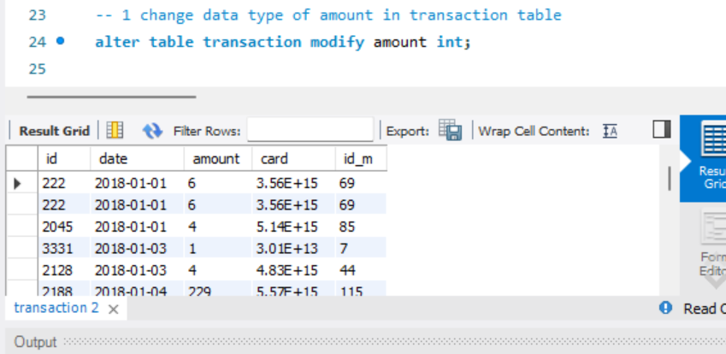

1. write query to find card_holder name start with ‘S’

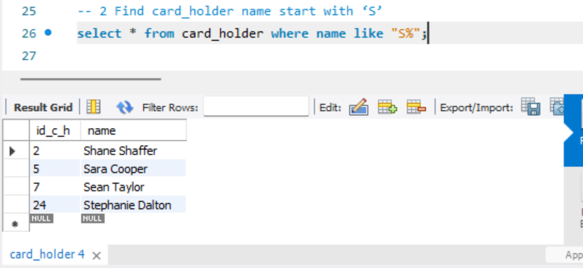

1. **Display Transaction sorted by their Amount in descending order**

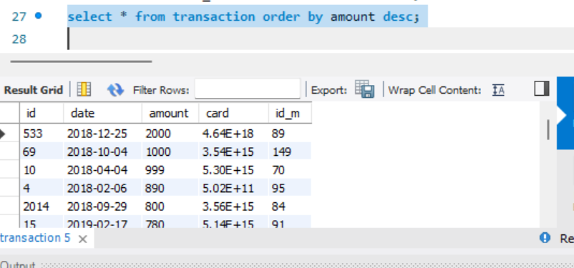

1. **Calculate the total number of card_holder**

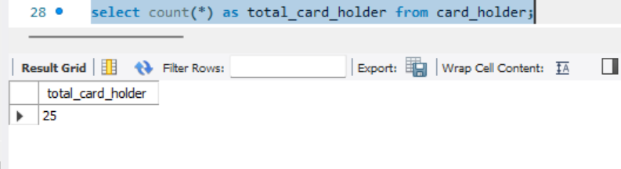

1. **Find the maximum amount in Transactions**

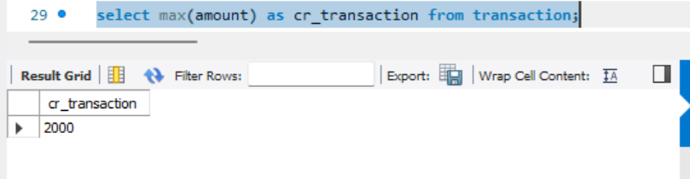

1. **Find the minmun amount in Transactions**

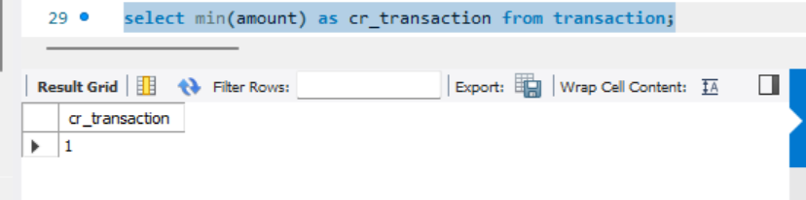

1. Write a query to fetch merchant_category and name in table merchant.

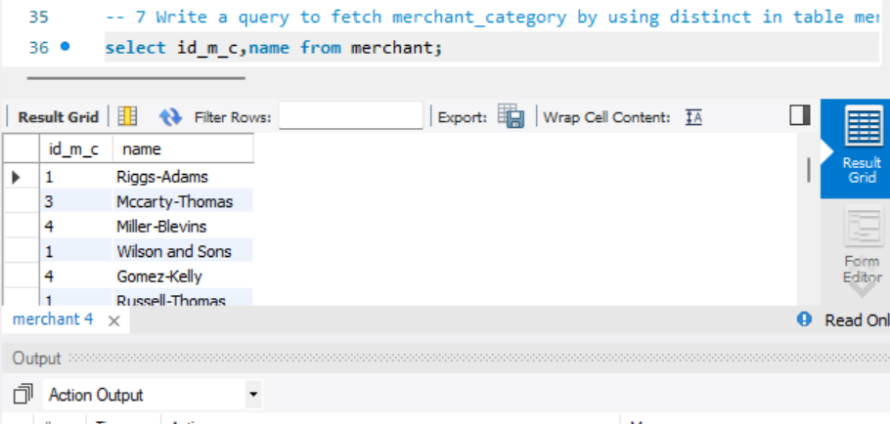

1. **Write query to fetch category of merchant with or operater**

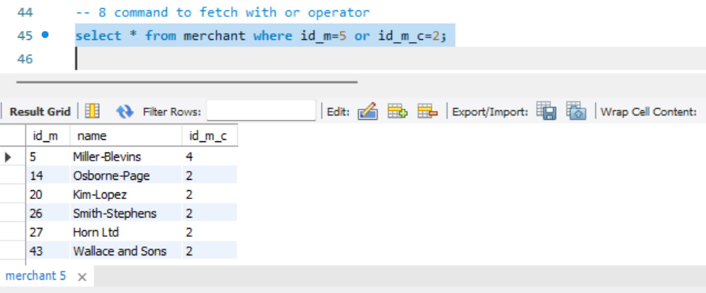

9. Count the total number of transactions

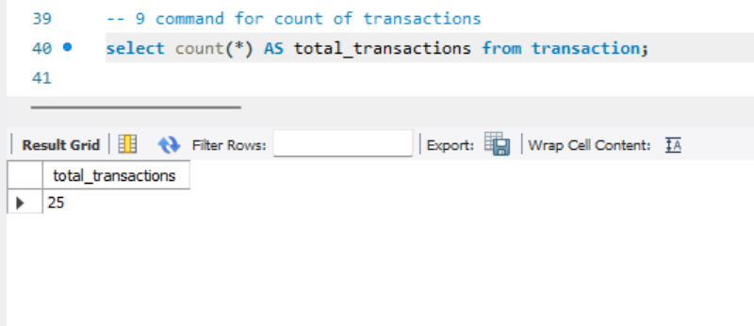

1. List all transactions made by a specific card number

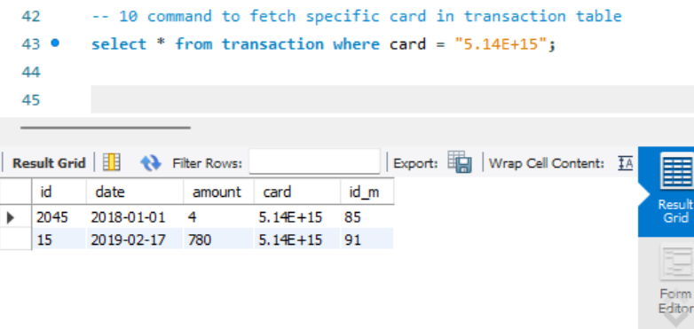

1. **Find transactions above a certain amount**

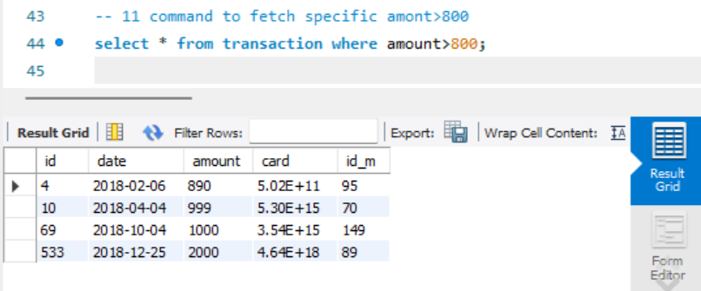

1. Write Query to gives name in upper case

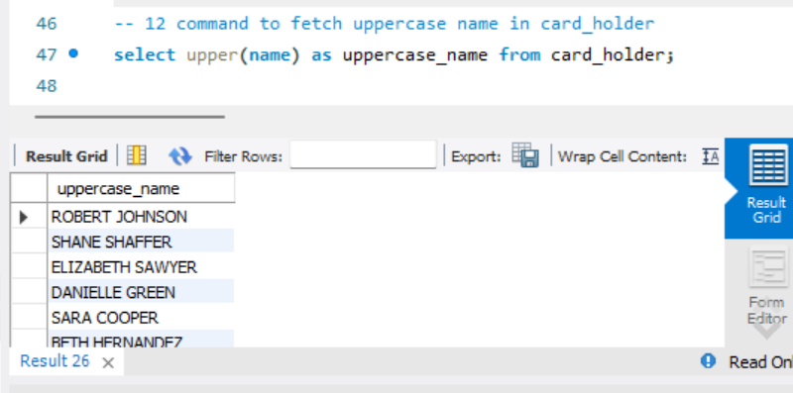

1. Write query to fetch data where transaction between 500 to 900.

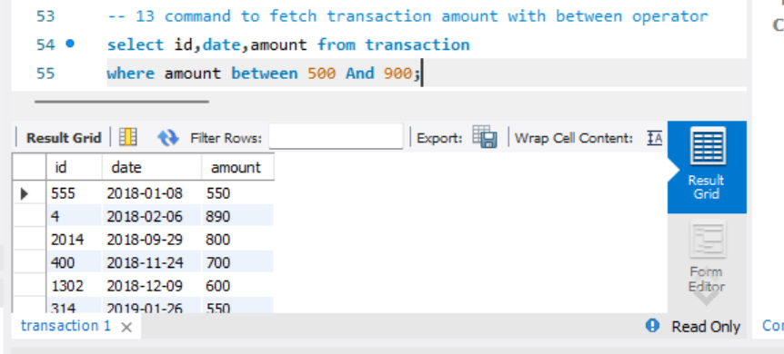

1. Write query to fetch data where transaction not between 500 to 900.

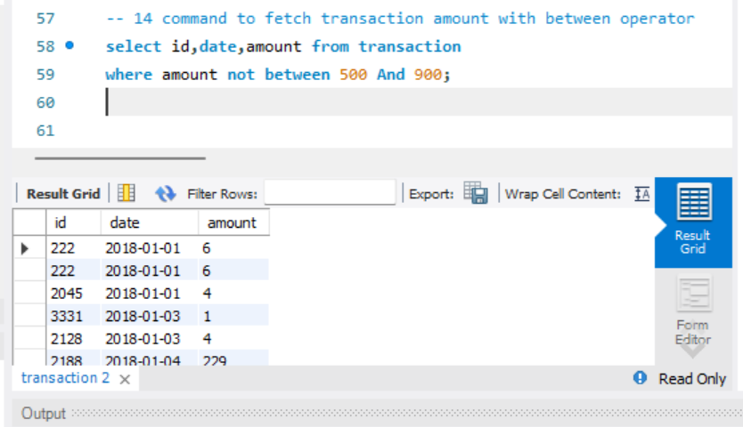

1. Write query to fetch data where transaction is 550 or 999 or 1000.

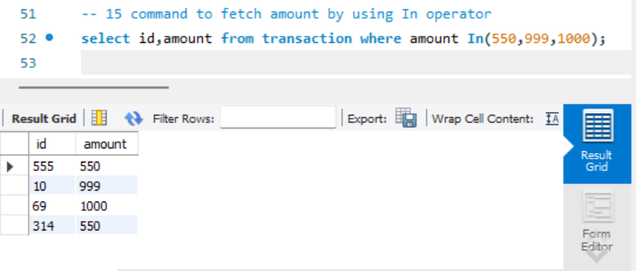

1. Write a query to fetch data where card_holder name end z.

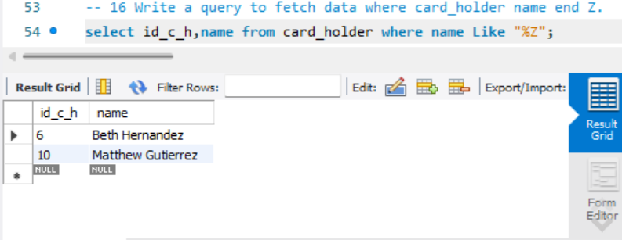

1. write a query to fetch top 5 record from transaction table.

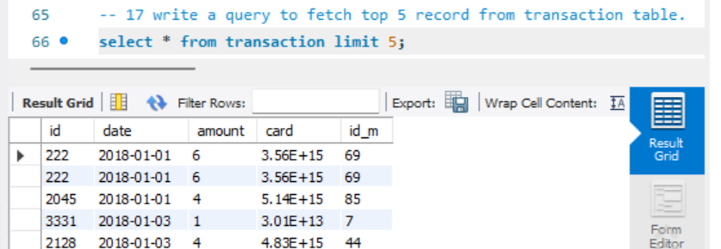

1. Write a query to show top 5 highest amount in transaction.

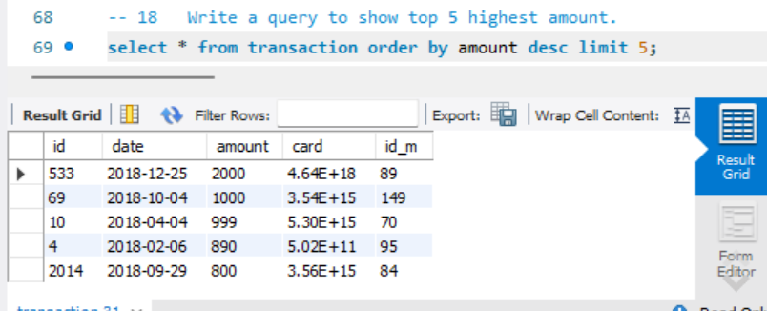

1. Aggregate Function

Write to query average of amount

Avg()

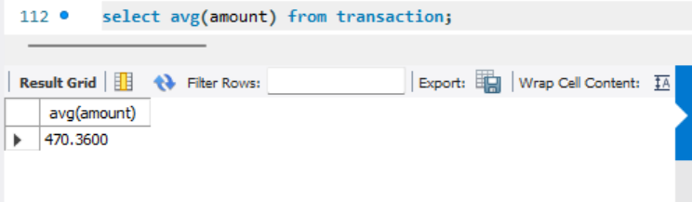

Sum()

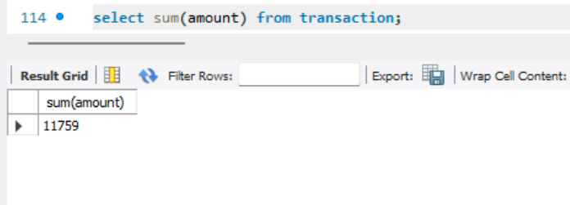

1. Date functions

Now()

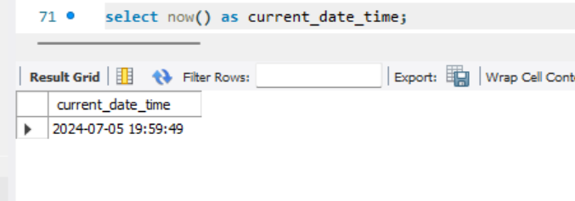

curdate()

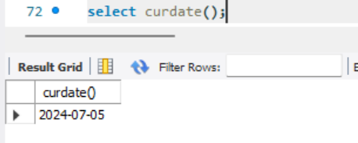

Curtime()  
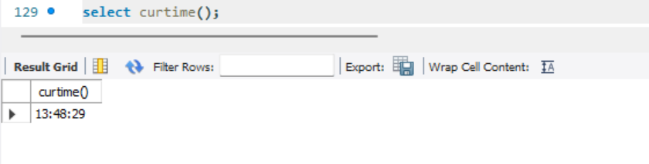

1. Write a query to show highest amount in table.

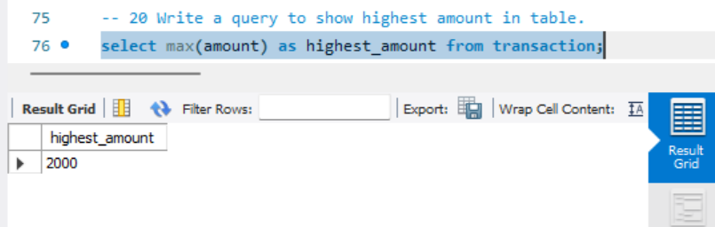

1. Write a query to fetch number of credit card.

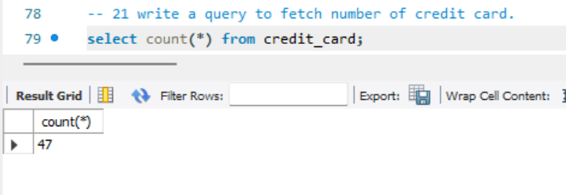

23. write a query to find highest amount of transaction by using subquery.

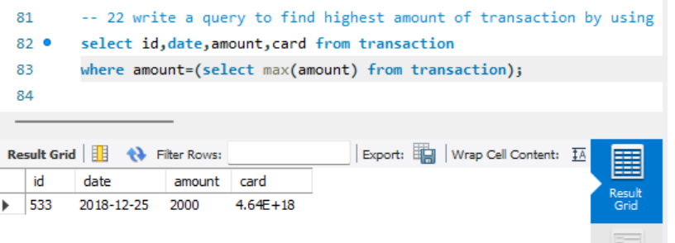

1. write a query to find 2nd highest amount of transaction by using subquery.

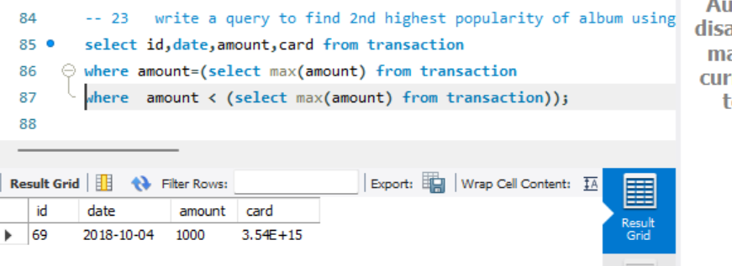

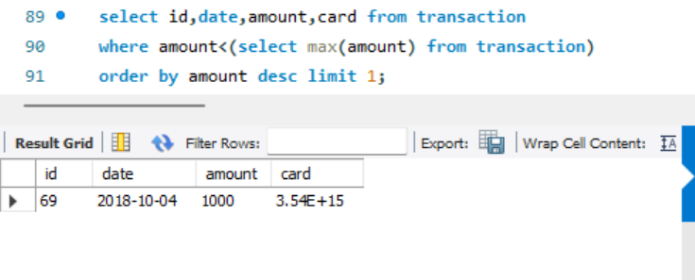

1. Retrieve Merchant Made with Merchant_Category.

Cross Join

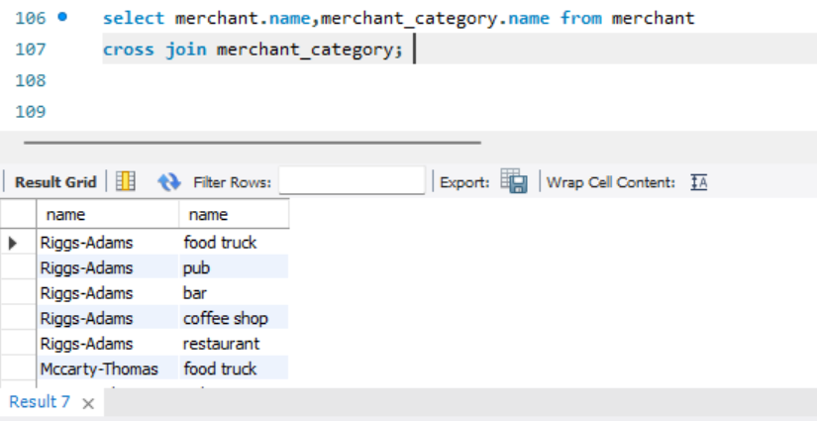

1. Retrieve Transactions Made with Credit Cards.

Inner Join

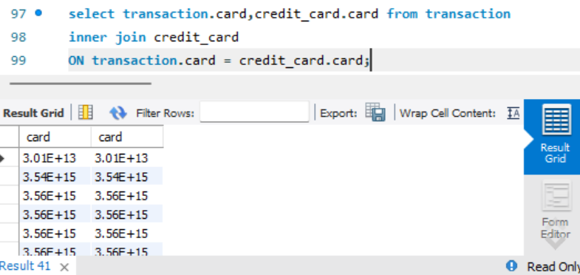

Left Join

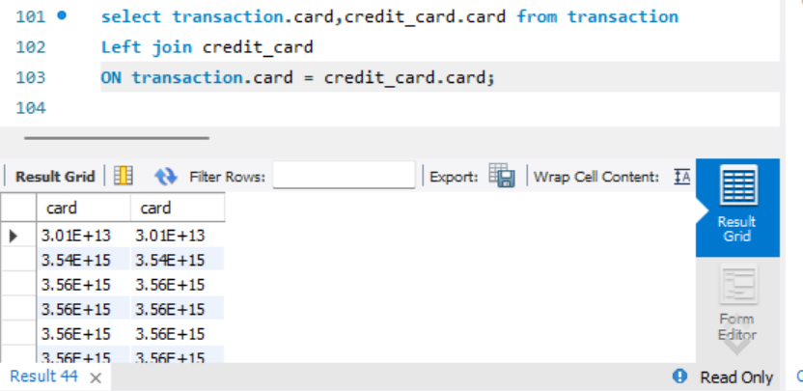

1. Create view.

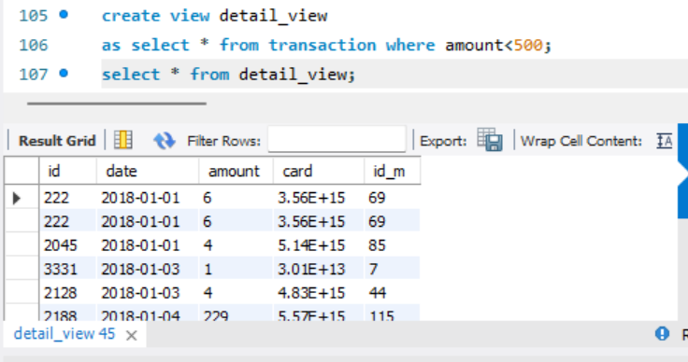

1. String Function

Concat()

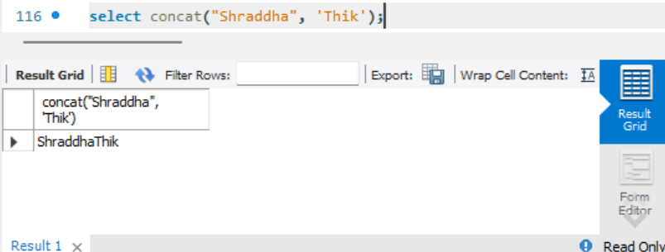

Length()

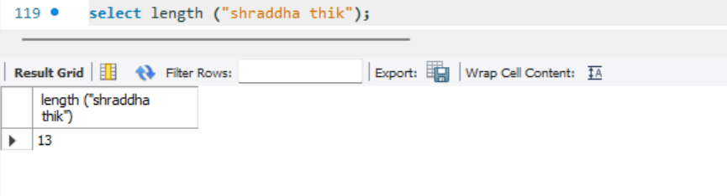

Reverse()

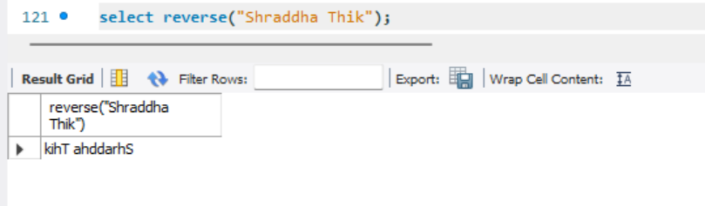

1. Math Function

Absolute()

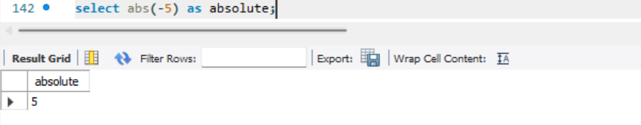

Modulas()

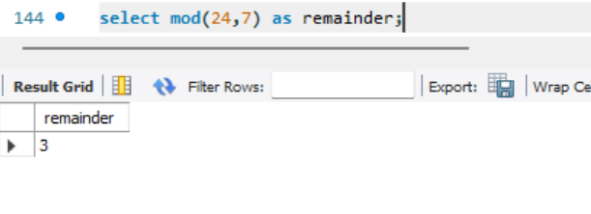

Square

